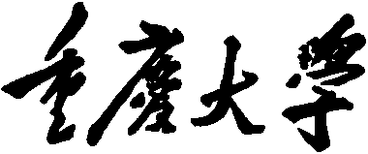


Personal Learning Portfolio

Course： English Academic Writing Teacher： Zhang Mei
Class： 001 Major： CS
Name： Student Number：
Class Time： 2024.02-2024.06
Grade：

Self | Teaching Assistant | Teacher
9

Comments：

Teacher (Signature)
Contents

The students’ teacher class

- My learning
- In class
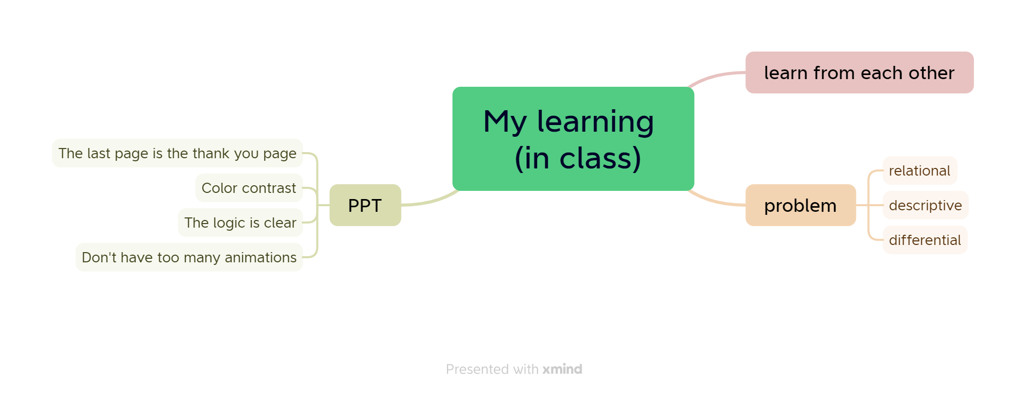

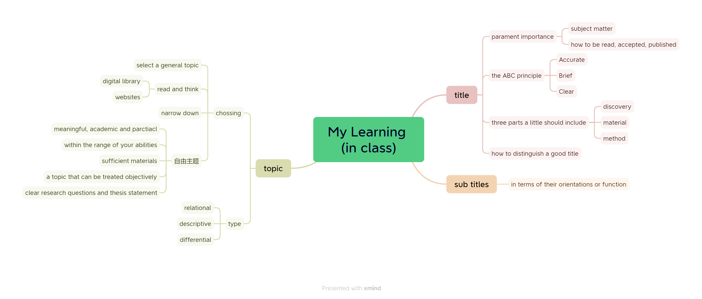

- Out of Class
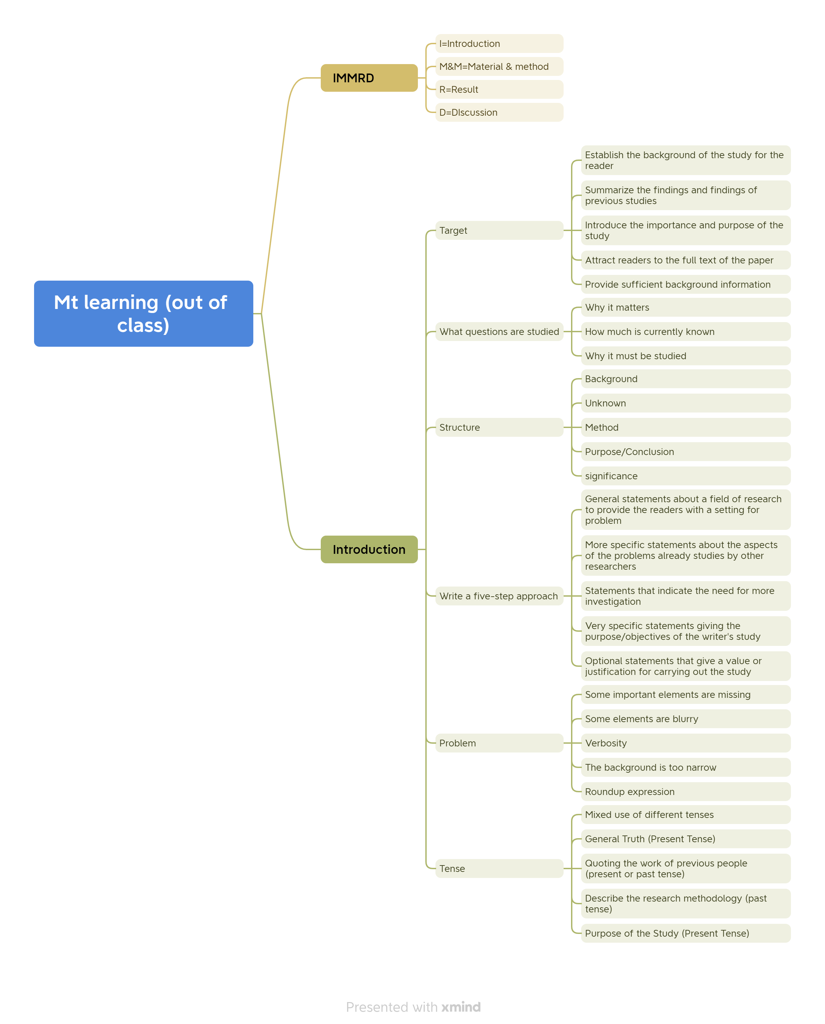
- Learning outcomes
1）In class
1) When I make a PPT next time, I want to pay attention to highlighting the theme and the background color should not be too cluttered.
2) When I was defending the topic selection, I knew that the PPT needed to be logical and well-structured.
3) When I think about a problem, I think about it from three perspectives.
2）Out of Class
1) When I read the foreword next time, I wonder if it has served the purpose of drawing me to the full text.
2) When I write a foreword next time, I know that it consists of background, questions, methods, and research objectives.
3) When I was writing the preface, I knew that most of the simple tenses were used and sometimes the past tense was used.

- My behavior and attitude
1）Out of Class
1.1 Autonomous learning (Online + Offline)
1.1.1 Online (CET-6 online course)
1.1.2 Offline (memorize vocabulary and listen to CET-6 listening exercises)
1.2 Homework
I completed my English assignment promptly with a diligent and meticulous attitude, ensuring it was not procrastinated until the deadline.
1.3 Cooperative learning
2）In Class
2.1 Individual performance (Take notes promptly and attentively focus during class).
2.2 Cooperation (Actively participate in classroom discussions)

4．Improvement
1）Out of Class
Through the study of MOOC, I know how to write a preface to an article, its composition and the issues that should be paid attention to when writing, and I can better write the preface of the article
2）In Class
In class, through each student's topic selection and defense, I know how to behave in order to satisfy others, including the clarity of PPT logic and the language of my own narrative

